Official league roster - Basketball
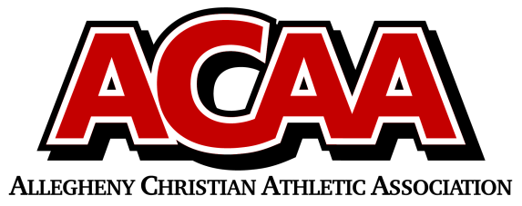

School Name: CACS
Team Colors: Black, White, Red
Overall Wins ___ Losses ____ Ties ___
ACAA Wins ___ Losses ____ Ties ___ OPPONENT: __________________________
Date: _________
Number | Name | Year | Position | Height | Homeschool
21 | Remington Crawford | 12 | F
23 | Richard Passmore | 12 | G
00 | Ethan Blowers | 12 | C
33 | Vincent Stone | 11 | F
10 | Brennan Michael | 11 | F
32 | Noah Michael | 10 | G
3 | Stephen Manno | 9 | G
12 | Liam Ramkawsky | 9 | G
15 | Aiden Millinder | 8 | F
30 | Cameron McTavish | 8 | F
40 | Luke Smeal | 8 | F
2 | Blake McGarry | 8 | F
25 | Sean Shaw | 8 | G

Head Coach: Chris Michael
Asst. coach: Dan smeal
Asst. coach:

Official ACAA League Team Roster. to be submitted to the scorer’s table before each game.

